By Kenneth Welch, Founder, Open Government in Blanco County TX; OGBCTX, LLC; https://www.opengovernmentinblancocountytx.org, January 19, 2024
The Mayor Has Gone Off The Deep End On US 281, AGAIN!

Mayor Arnold has sent a long and rambling email to TxDOT and several other officials “as a dissenting opinion” regarding the possible US 281 relief Route around Blanco. Here is the recommendation approved by the City Council.

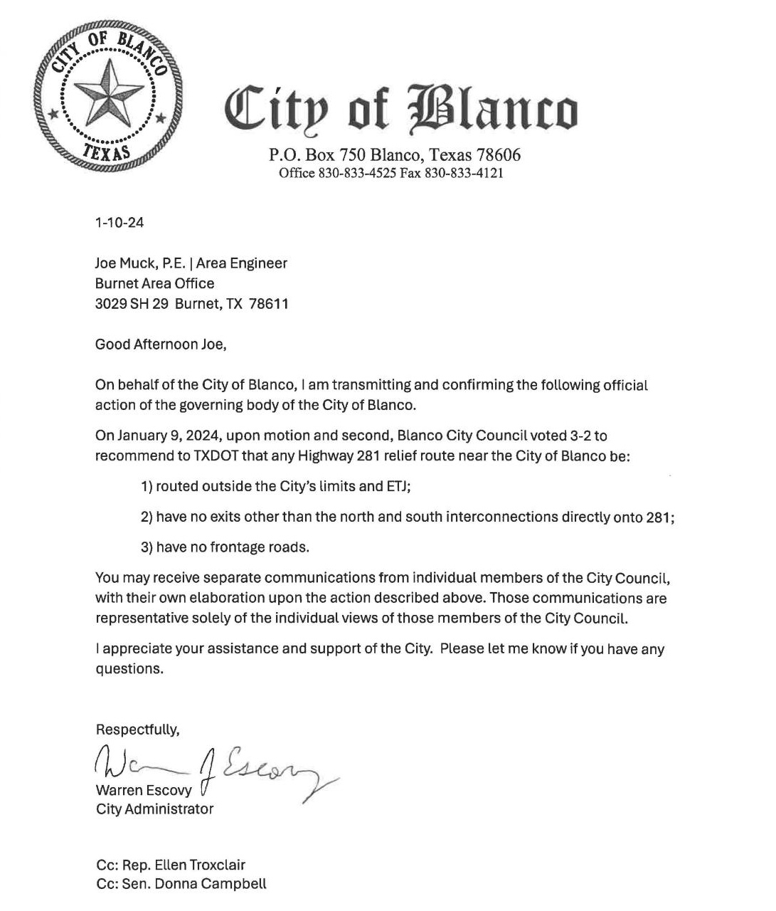

On June 9, 2023 Mayor Arnold notified TxDOT of the City’s position on a relief Route without the involvement of the City Council. His unauthorized actions caused some heated discussions and resulted in a resolution that requires any action relating to the US 281 relief route be approved by the City Council. Following that event and a series of other communications by Mayor Arnold, I posted an article laying out the timeline of events and the facts including the supporting documents behind the first four months of Mayor Arnold’s administration. At that time I was hopeful that his mistakes were just that and he would move forward as a leader, not a disrupter. Mayor Arnold has again shown that he would rather push those around him rather than lead the City Council and the staff. He still does not seem to understand the difference between leading and dictating. He has no vote on the City Council (unless there is a tie) and no authority to act unilaterally.

Although it is clear that each member may have their own views on issues and they have the right to express those views, Mayor Arnold’s approach is to openly disparage, discredit, and attack anyone who disagrees with his views. One of the City’s Goals, as stated on the website is “Promote open and honest communication with Blanco Citizens to foster a fully informed and engaged citizenry”. ”Honest” is the operative word.

Here is the Mayor’s long email following the City Council approval of their position. I have noted the false, exaggerated, and miss-stated information. With this email, Mayor Arnold has violated the intent of the City Council's Aug. 8, 2023 resolution, if not the explicit ban, on communication with TxDOT regarding the possible relief route.

To: Joe Muck, TXDOT
From: Mike Arnold, Mayor, City of Blanco
Co-signed by: Ryan Moses, Blanco City Council CC: Rep Ellen Troxclair, Sen. Donna Campbell
A copy was also sent to Blanco County Commissioners Weir and Riley

Greetings:

Late at night on Jan. 10, after a lengthy Executive Session, with no members of the community present to witness it, three members of the Blanco City Council voted to officially demand from TXDOT that any Highway 281 relief route near the City of Blanco be:

- Routed outside the City’s limits and ETJ (that’s at least a half mile beyond the city limits);
- Have no exits other than the north and south interconnections directly onto 281;
- Have no frontage roads.

I offer this letter, not as an official city position but as a dissenting opinion, so you may put this in proper context.

I attended the City Council meeting and there were at least five other members of the public in attendance. The proposal was presented during the open meeting. Discussion centered on the wisdom of the City taking a position. Both pro and con were presented and the discussion was totally respectful of differing views.

Although this email is “not an official city position” it approaches the line established by the Council’s previous admonition by discrediting the qualifications and integrity of the council members that disagreed with his opinion. TxDOT has asked that the public comments on the possible re-route be directed to Megan Dutton, US 281 Blanco Relief Route Study, 1608 W. 6th Street, Austin, TX 78703. This email was clearly intended to step outside TxDOT’s guidance by addressing it to Senator Campbell, Rep. Troxclair, and our County Commissioners. None of these individuals are involved in the TxDOT evaluation process. Mayor Arnold and Councilmember Moses are playing politics with this matter. The decision should be made based on the factors identified by TxDOT, not politics.

This action, by three relative newcomers to Blanco – councilmembers Swinson, Smith and Thrailkill – was taken directly against the strong advice of our senior staff, professional advisors and Mayor. It was technically not an illegal vote, but certainly shady, misguided, ham-handed, and possibly damaging to our town.

Coucilmember Moses made no comment during the open session. Likewise, City Administrator Escovy took no position. Tim Tuggey, City Attorney, indicated that there are some significant legal issues associated with whether the City takes a stance that he would like to discuss in an executive session.

The two remaining Council members voted against this – one the longest-serving (Keith McClellan), and the other the highest vote-getter of any current councilmember (Ryan Moses, 235 votes).

These two longtime Blanco residents had previously moved and seconded a proposal that this vote be delayed just two weeks until the city’s appointed Transportation Committee could seek public input, review the extensive research done by TXDOT, and then provide a fact-based recommendation to Council. The three voted against this reasoned, thoughtful, professionally advised, and inclusive approach.

A 281 Task force was established on Aug. 9, 2022 under the previous administration. It was active, gathering data and input from hundreds of Blanco County residents. On June 29, 2023, upon my request for a Task Force meeting, I was assured by Mayor Arnold that a meeting would be scheduled in the near future. During Mayor Arnold’s tenure, no 281 Task Force meeting was ever called. In fact, Mayor Arnold wrote in a text message, “The Council has their’s, to which they (not I) appoint members, but I am the chair...so if they don’t make it how I want it, I just won’t call a meeting”. Receiving no guidance or input from Task Force Chairman Arnold, several members of the Task Force continued to work within the community, as an independent citizens group, gathering data and input and providing it directly to the TxDOT team.

During the Nov. 14, 2023 City Council meeting Councilmember Swinson made a recommendation that the 281 Task Force be formally dissolved and a new Transportation Committee be established to focus on all transportation issues, including US 281. Membership for the new committee was discussed and it was decided to determine the interest of all members of the old task force. Mayor Arnold, as interim Chairman, scheduled the first meeting for Nov. 30, 2023. He set the agenda for the committee to focus on the future of the current US 281 through downtown. During the meeting he indicated that the relief route location is already determined with an exit at RR 165. When challenged by those in attendance he qualified his statement, indicating that his statement was merely his opinion.

This item was inserted into the agenda by Councilmember Swinson, with the bare legal minimum of public notice – vaguely worded as “…possible action on recommendation to TXDOT regarding possible relief route on Hwy.
281” – such that no member of the public showed up to speak on this hot-button issue.

Think about that. Our citizens have proven keenly interested in this process, and have showed up in large numbers every time it’s been discussed. There’s no doubt that had this agenda item been honestly presented and the community truly notified, many would have shown up to this meeting to share their insights. I believe they deserve to be heard.

At least six members of the public were in attendance prior to Mayor Arnold taking the discussion out of public view by moving the discussion to an executive session. The agenda indicated there would be discussion and it was posted in advance, just as all City Council meetings are posted. No members of the public spoke as they waited to learn what, if any, recommendation was to be discussed. Mayor Arnold, as Chair, has the authority to call upon members of the public in attendance to obtain “their insights”. He did not do so!

TXDOT has told us they have cut Blanco out of the decision making for this project as a direct result of petty political grandstanding, which was stirred up by councilmembers Thrailkill and Swinson to begin with. Even before steamrolling this through with no public comment and contrary to professional advice, they’ve horribly damaged our standing to influence the details of this relief route. Now they’ve undermined us even further.

The “political grandstanding” started in the Spring of 2023 when Mayor Arnold chose to represent his personal route selection as the official City position. He then denied his action but his written exchanges with TxDOT revealed the truth. On Aug. 8, 2023 the City Council voted unanimously that “Further action by the City on any such project, if any, shall be subject to authorization by the governing body of the City”. Councilmember Swinson acted appropriately when she presented her proposal to the City Council in the public forum, unlike Mayor Arnold’s direct contact with TxDOT advocating for one specific route.

Councilmembers Moses, McClellan and I, along with our senior staff and professional advisors, implored these Council members to do the work to secure actual public input and review the available research, so that we could come to a real consensus. With that, we could have stood arm-in-arm to advance the City’s interest, and perhaps actually earn back a seat at the table, to make a real impact. Now we will never have that chance.

If the specific demands these three advocate are indeed the will of the people of Blanco, then we owe it to our citizens to advance this position as effectively as possible. By dismissing the strong advice of our highly paid professional advisors and ramming this through in such a rushed, divisive, secretive way, our dire concern is that this further belittles Blanco’s opportunity to secure a Relief Route that best serves the real needs and desires of our citizens. How can TXDOT take us seriously as a community if this is how the radicals on City Council do things?

No “demand” has been issued to TxDOT. The letter authorized by City Council was sent on Jan. 10th and it uses the word “recommend”. The letter can be viewed on the City web site.

TxDOT has indicated they will soon be reducing the alternate routes that they previously provided from six to three. Failure of the City to present a position to TxDOT would deprive TxDOT of important information from the governmental entity that originally requested the study for a relief route to protect Blanco from the anticipated traffic increases through downtown. The study has been conducted over the past twelve months. This decision was not rushed. Mayor Arnold decided to take the discussion into an executive session, out of view of the public. To characterize the decision as “secretive” is nonsense. All five members of the Council were afforded a vote. The three votes cast to approve the official statement were all cast by experienced City Councilmembers, unlike the vote cast and opinions offered by first term members, Mayor Arnold and Councilmember Moses.

Bafflingly, Councilmember Thrailkill (who received only 72 total votes when elected) proudly announced that he spent most of 2 days calling 12 people to get their opinion on this … and then had the audacity to proclaim he was 100% confident that he knew the will of the people. Wow.

By contrast, I remember five years ago driving around with then-Mayor Martha Herden to look at possible routes for this bypass. When I was on the Board of the Chamber of Commerce, more than a year ago we published a map on the front page of the newspaper and received quite a few submissions from residents sketching their preferred route (none of which meet the Council’s demands!). A quick glance at interactive data TXDOT offers on their website shows that our citizens have widely diverse opinions. I’ve personally been researching this and talking with citizens – and TXDOT, and other experts – for years. I don’t personally have a strong opinion on precisely where it should go – thankfully, it’s not my job to draw that route – but I can tell you with certainty: What these three have advanced as the “official position of the City of Blanco” is FAR from a consensus, nor is it an informed opinion.

The mapping effort put forth by the Chamber of Commerce over a year ago had submissions from eleven individuals. Mayor Arnold has consistently stated that those eleven reflected a consensus. Mayor Arnold is now saying, “I don’t personally have a strong opinion on precisely where it should go”. However, that is not what he told TxDOT on June 7, 2023 when he wrote “there is a logical route that makes sense to pretty much everyone, and we have it fairly well mapped out by a surveyor. I was hoping I could help steer your feasibility study to put emphasis on this one and not waste time and money doing deep dives on ones that I know will be non-starters. Present them as possible alternatives, sure, but I can say with a high degree of certainty that we know what we want and the route appears certainly feasible”. He is also stating “it is not my job to draw the route”. He personally solicited the services of a local surveyor to digitize his preferred route for a meeting with TxDOT on June 12, 2023. In a text message to the surveyor he said “Hey - I’m meeting with TXDOT on the 12th. Can you print me a copy of that alternate route map we did awhile back? THANKS”

There are an enormous amount of variables and issues to consider. Every option has drastic trade-offs. This is as serious as it gets. If we get this wrong it will damage our town forevermore. The variables are like a three dimensional chess game, yet these three are playing tic-tac-toe with crayons, with the future of Blanco at stake.

I had been looking forward to engaging the community in a meaningful dialogue on this subject, with plans in motion to work with our Transportation Committee, engage TXDOT, and hold a town hall meeting, to do just that. There is quite a bit of wisdom and expertise in our community, and we should have had the opportunity to put our minds together on this. We will now never have that chance.

When the Transportation Committee was authorized, the City Council discussed the membership and agreed to ask the former Task Force members if they wanted to be on the new committee. Although the former members were invited to the first meeting, the mission, responsibilities, and expectations have not been defined. At the first meeting all in attendance were in agreement that a follow-up meeting should be held on Jan. 3rd, 2024 to choose a new chairman and further discuss committee organizations and responsibility. Mayor Arnold, as acting Committee Chairman, did NOT schedule a meeting for January 3rd.

Following the executive session on Jan. 9th Councilmember Moses moved to table the issue to give the Transportation Committee time to do the research, obtain public consensus through a town hall meeting, and make a recommendation that the City Council could embrace. Mayor Arnold indicates the Moses proposal would have delayed the vote “just two weeks”. After a year of non-action two weeks without a fully organized committee could not be productive.

On June 10th Mayor Arnold approached me to advise me of the actions taken by the Council the prior evening. At that time he said the Transportation Committee would meet on June 16, 2024. Once again, he did not call the meeting.

The concern held by many with pushing the bypass so far from our city limits is that Blanco may become the next Vanderpool. Where’s that? That’s the point. Folks driving down the new 281 won’t turn at a sign that says “Blanco 2 miles that way…” to fill their gas tank or grab a quick lunch. How many times traveling down 281 have you turned and driven the 1.1 miles to the old City of Bulverde (and not the strip centers on the highway) to buy gas, or lunch, or hardware, or stay at a hotel? (What, you may ask? There’s an old City of Bulverde just a mile off 281? I never knew that! – my point exactly…) At least Bulverde had the brains to gain taxing power over the right-of-way.

If TXDOT heeds these three councilmembers, many of our biggest employers and taxpayers – like 7-11, Dairy Queen and Tractor Supply – will be forced to relocate to the new route (where we can’t collect tax or have any say in how it looks), or they will simply go out of business. This will be crippling to our city economy and gut our already stretched city budget.

During the first Transportation Committee meeting Mayor Arnold made these same statements. The expansion of US 281 south and north of Blanco will bring additional traffic to Blanco. There was little agreement on the unknown economic impact of the changes. It was suggested that an economic analysis should be conducted by qualified experts with experience in similar situations. No matter which route is selected, growth will come to Blanco County and Blanco businesses will benefit from that growth.

The further around town it goes, not only does that make us more of a ghost town, but it also exponentially increases the square feet of impervious asphalt ground cover, toxic highway runoff, clearcutting of old oak trees, homes bulldozed, etc.

What’s the optimal distance from town? If we as a community decide it is indeed that far away, is this economic and environmental damage the price we are willing to pay to wash our hands of the highway once and for all? I don’t know, and sure as heck these three don’t know. But they’ve already decided this for all of us.

All members of the City Council are elected to make difficult decisions and all three of these members have been re-elected as a result of their experience and past performance. I believe the City should absolutely be making a recommendation to TxDOT. The Council has discussed the matter and have made a recommendation, not a “demand” as Mayor Arnold has indicated.

Furthermore, telling TXDOT we don’t want exits at Hwy 32 or 165 is silly. TXDOT will make those decision without us. Their mandate is to move traffic as efficiently as possible. There will likely be intersections and/or exits at one or both of those locations, like there are at 473, 311, 306, Rebecca Creek Road, 46, etc. And where there are intersections and exits, there will be NEW gas stations, restaurants, etc., taking paychecks and jobs from our citizens and crippling our city budget.

What are the full implications of these knee-jerk demands? Fact is, we don’t know -- because we didn’t do our due diligence or even discuss it.

No “demand” has been made! Mayor Arnold could have used the US 281 Task force to do the “due diligence” including an economic analysis. He instead chose to ignore all protocol established by state statutes to achieve his desired outcome by “ramming this through in such a rushed, divisive, secretive way” last June.

We could easily have gained full access to the sophisticated traffic pattern data, etc., from TXDOT and CARTS if we had simply asked for it. That’s supposedly why we have the Transportation Committee! But these three don’t care. Gee, one of them talked to 12 citizens over two days, so of course they know what everyone here wants!

That’s why we had a US 281 Task force under the chairmanship of Mayor Mike Arnold. He did nothing to pursue a legitimate cooperative effort between the City and TxDOT. Mayor Arnold proclaimed that maps submitted by only 11 citizens supported his selected route with “a high degree of certainty”.

As no public input or TXDOT data has been formally solicited or reviewed by the City, and our diverse and capable Transportation Committee was cut out of the loop, this 3-2 vote cannot in any way be interpreted to represent the will of the community, but of only these three out-of-towners (two of whose terms expire in just a few months), who have proven time and again to be out of tune with the bedrock values of our community.

Is this the same “diverse and capable” group of individuals that Mayor Arnold described in his text messages in May 2023 when he wrote, “The past administration packed it with folks based on political leanings and not practical experience or local connection.”

Fact is, we really don’t know what route is best for Blanco, or what our citizens want, and now it looks like we never will.

